Hair Restraints Policy Lesson

- Policy
  - All persons who encounter processing equipment, food contact surfaces, utensils, in-processing materials, raw materials, packaging materials, and finished products are required to do hair restraints at all times.
  - All visitors and guests of Fat & Weird Cookie Company abide by the policy set forth in section 2.1 while visiting the premises.
  - Uniforms, including footwear, and hair coverings that are provided to employees in food manufacturing sites are primarily for the protection of materials, work-in-progress (WIP), finished product, and food contact surfaces
  - Employees and visitors wear clean clothing, footwear, and hair covering if identified as a risk while in the processing area.
  - Hairnets and beard snoods are worn by employees working on the packing or processing line or who work around exposed products.

- Procedure
  - Definition
    - The definitions and interpretations of terms in this procedure are applicable to such terms when used in this part. The following definitions shall also apply:
      - Wearing, where appropriate, in an effective manner, hair nets, headbands, caps, beard covers, or other effective hair restraints. (Reference: 21 CFR 117.10 (b) (6))
      - Hairnets and Beard covers - a piece of fine mesh fabric for confining the hair.
        - Purpose to keep hair from contacting exposed food, clean and sanitized equipment, utensils and linens, or unwrapped single-service articles and to keep workers’ hands out of their hair.
  - Equipment / Materials
    - Dispenser – Hairnets & Beard Covers
    - Hairnets
    - Beard Covers
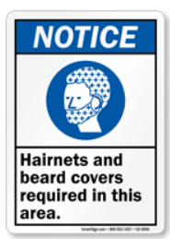
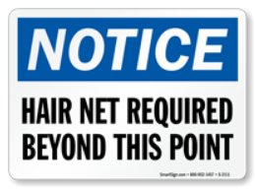
    - Mirror – Stainless Steel
    - Requirements
      - Dispenser
      - Model / make / supplier
      - Item No.______________
      - Location: _________________
    - Notice – Hairnets and Beard Covers
      - Must be cleanable.
  - Beard Cover Donning
    - When donning a beard cover ensure that the entire beard or facial hair is covered.
    - Once the beard cover is donned, proceed with the hairnet donning procedure.
    - Personnel with facial hair shall perform this procedure first.
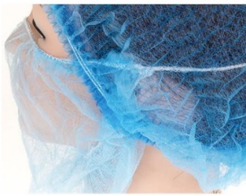

  - Hairnet Donning
    - Brush and tie the hair back, as the hairnet elastic will lay flat against the neckline.
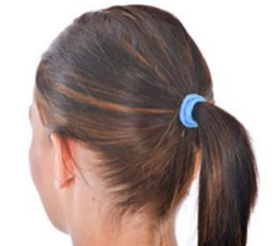

    - Hold the hairnet open ready for donning with the closure from north to south.
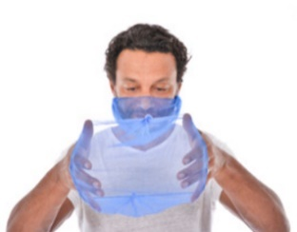

    - Locate across the forehead and pull the hairnet over the crown, ensuring all hair is covered.
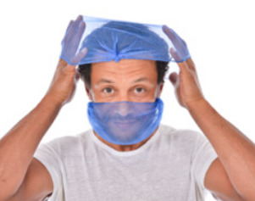

    - Locate under the ears and secure in place.
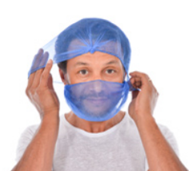

    - Check all hair is fully enclosed.
    - Use a mirror or ask a colleague for a visual check.
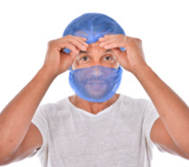

    - Put on the lab coat and other PPE after the hairnet has been worn. This ensures that any hair dislodged by donning and adjusting will not enter food production areas.
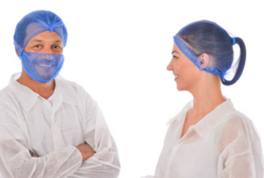

  - Frequency
    - At any moment
      - All personnel shall abide by these procedures when performing their responsibilities
    - Daily
      - Food Safety Team Lead, or SQF Practitioner
        - Ensure consumables are inspected and available
    - Monthly
      - PCQI / Quality / Maintenance / Facility Personnel
        - Verify dispenser station security, integrity, and functionality.
        - Document all discrepancies and corrective actions on the Corrective Action & Preventive Action Form
        - Repair or replace the dispenser, as necessary.
    - Annual
      - Food Safety Team Lead, or SQF Practitioner
        - Verify training records
        - Train / Retrain personnel

- Responsibility
  - All Personnel
    - Must don hair restraints when encountering processing equipment, food contact surfaces, utensils, in-processing materials, raw materials, packaging materials, and finished products.
  - Housekeeping / Designated Department Personnel
    - Ensure hairnets and beard covers are replenished, dispensers refilled, and available along with the approved consumables (Hairnets, Beard Covers, Gloves, Soap, Disposable Paper Towels, Sanitizer, Disinfecting Agents, Trash Bin Liners) frequently as necessary.
  - Quality Assurance Manager – Food Safety Team Lead or SQF Practitioner
    - Inspect hairnets and beard covers are available on all PPE locations.
    - Ensure hairnets and beard covers utilized by personnel are intact (no tears, rips, or missing pieces)
    - Visually inspect personnel for compliance with this policy.
    - Ensure personnel is trained on this policy and procedures.
  - Supervisors or department heads and team leaders are responsible to ensure (inspect) and verify this policy and procedure is adhered to and;
  - Ensure (inspect) and verify that consumables (Hairnets, Beard Covers, Gloves, Soap, Disposable Paper Towels, Sanitizer, Disinfecting Agents, and Trash Bin Liners) are refilled and replaced frequently.
  - Quality Control Personnel.
    - Validate that consumable (Hairnets, Beard Covers, Gloves, Soap, Disposable Paper Towels, sanitizers, Disinfecting Agents, and Trash Bin Liners) are refilled and replaced frequently.
    - Validate training and adherence to policy and procedure.
    - Monitor and document non-conformance observation, also known as discrepancy, using corrective and prevention form.
  - QC / Compliance Department.
    - Document all records.
    - Document control and archive.

- Corrective Action
  - Train all personnel on this policy
  - Non-compliance will require re-training or dismissal from job duties or termination of employment.

- Review-Quality
  - Company policies on clothing, including uniforms, gloves, hairnets, snoods, and footwear, are in place and are appropriate for the type of operation;
  - Items such as hair nets, snoods, and disposable gloves are available at accessible locations;
  - Disposable gloves and hairnets are correctly disposed of;

- History
Revision No.: | Revision Date: | Description of Change: | Originator / Author Name: | Title / Department:
0 | 20230111 | Original | Arnel Ryan | PCQI / Compliance
1 | 20230328 | Aligned with the current program and procedure | Arnel Ryan | PCQI / Compliance

Requirements:
- The trainee (employee/visitor) has read or received a verbal translation of all or part of the policy, procedure, method, and/or SOP for which they are being trained.
- The trainee has observed a demonstration of the task they are to perform or the procedure for which they are being trained as required.
- The trainee has demonstrated the ability to perform the task with acceptable proficiency and minimal supervision.

